***Experiment 8***

**Aim:** Machine Learning Model Training with Spark MLlib: Train machine learning models on large datasets using Spark's MLlib library, and evaluate model performance using techniques such as cross-validation and model selection.

***Spark Machine Learning Model:***

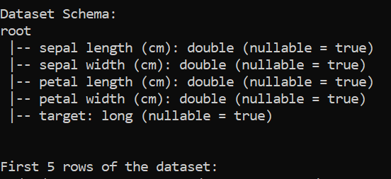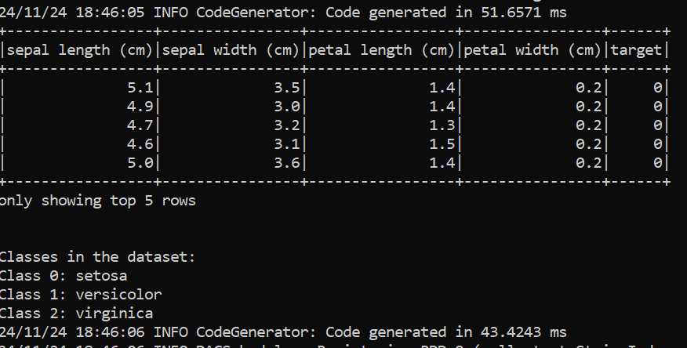

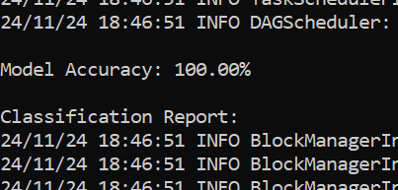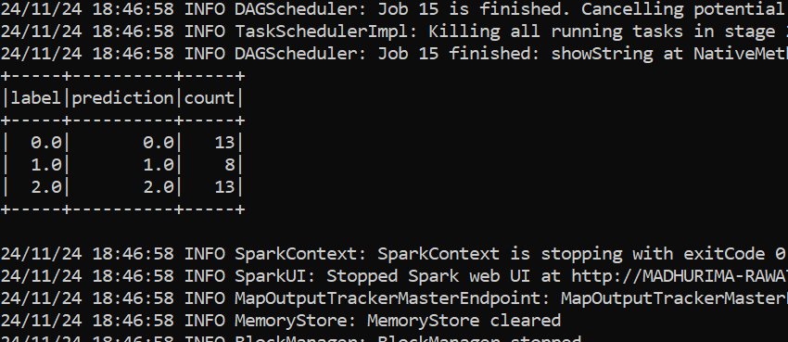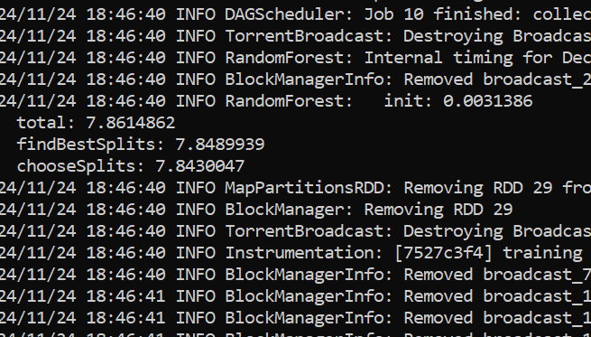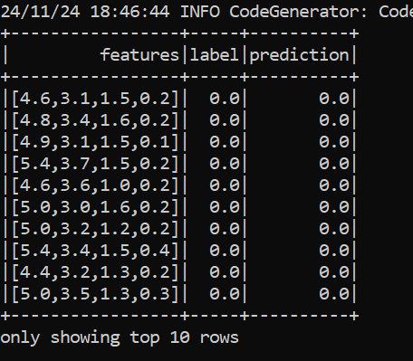

***Fig 2: First Rows and Classes of Dataset***

***Fig 3: Best Models and Parameters***

***Fig 4: Classification Report with prediction***

***Fig 1: Dataset Schema***

***Fig 6: Label Count and Prediction***

***Fig 5: Model Accuracy***